Soap only supports Xml and Post method





contract



Xml carries both data and metadata, allows to create custom markup



XSD

Xml schema definition, defines the blueprint of an xml document.

What elements, attributes, namespaces, order, number of ocurrences of each element and the restrictions.

 



Order xsd says what elements, attributes and in which order, elements can show in the .xml

Xsd is used because when app1 and app2 are exchanging xml each other, then one could follow a different approach which will affect the result, with the xsd we have a contract that controls what elements can be accepted.

Namespaces





From here we can use amz instead of the whole target namespace in order to refer to its value



Schema xml example:

xsd



Xml



If xml doesn’t follow the xsd template it will give an error when validating



Max occurs, min occurs control how many times the element can show up in the xml



elementFormDefault

If the schema is marked as qualified then each elements in the xml should have the prefix (txn this case because of the xmlns:tns)



Unqualified allows to have the xml without the prefix



attribute





Id Added as attribute on the root element





Soap:body has de payload





Soap header helps to send metadata

WSDL





Types

Here you add the types you need to exchange information ex: string

Messages

Parameters and return types

Operations

Methods the service has

Port type

holds the operations the service has

Binding

How the service can be consumed

Service

Tells how to access the service, which url

You can have multiple services in the same wsdl using the port element

Binding style determines payload, messages and if the schema can be validated or not









Approaches to develop soap ws







When wsdl is generated

Webmethod become operations

Web param, web result and Webfault become messages



Responsewrapper allows to customize the response returned



Create project

Copy the wsdl into the project to with it generate the stubs

With the tool or maven plugin generate automatically the stubs from the wsdl



Create the client



From the wsdl obtain the service and then the port type which will have the methods or operations available on the wsdl to invoke

Down to top ws creation (first java then wsdl)



Mark request and response (beans) with annotations



@XmlElement is optional only if you want to control the name of the field, if not the name of the var will be used by default only using @XmlType on the class

Mark endpoints with annotations



Add configuration



After running the cfx plugin will find the classes annotated with @WebService and will generate a wsdl based on it

Configure security on web service





On the ws config class add after the published endpoint the interceptor with the class which will provide the required authentication info.

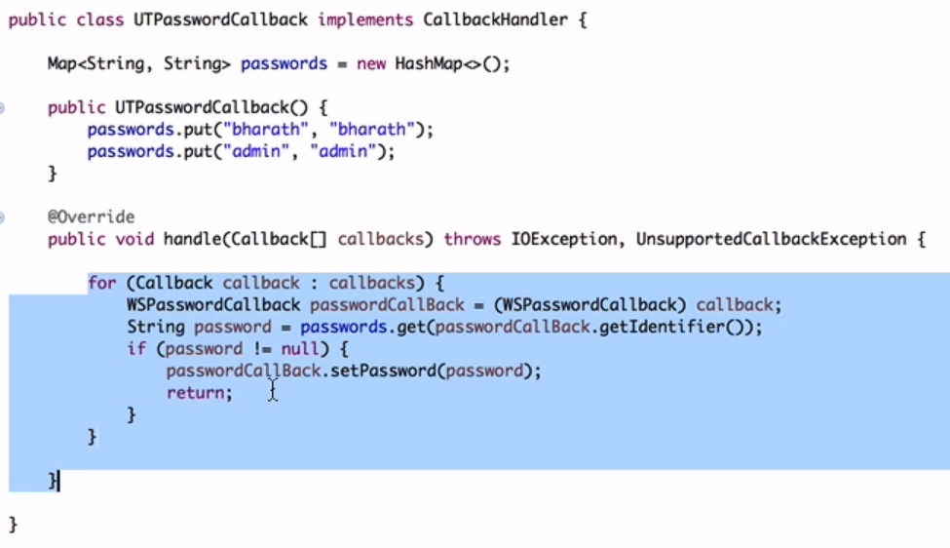

Configure the callback to retrieve and set the password on the callback

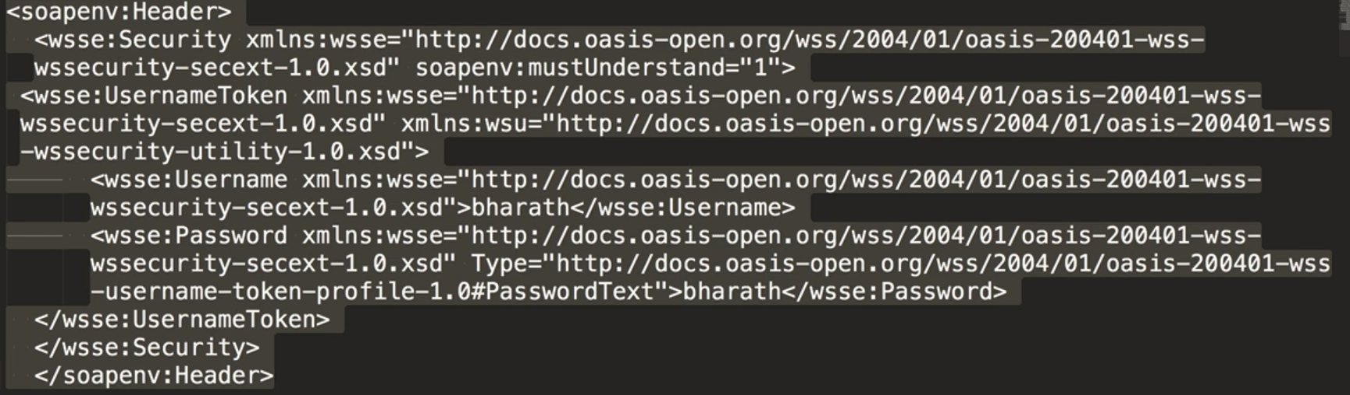

Send the username and password on the header to be retrieved on the callback

Jax ws handlers

Similar to interceptors, allow to modify header or body (for cross cutting concerns)











@Suspended says Jax Rs this method is asynchronous

Method should be void and response.resume will be in charge of returning the response when ready



Client for the asynchronous call





Basic auth

Federated Authentication

One application using another application to login:

ex: you try to post a comment on a website which redirects you to google to authenticate then google confirm authentication to the website which allows to post the message with that user from google

Delegated Authorization

You use a website which will return docs which allows to save to google drive, instead of sharing the data from google drive to the site, the site redirects you to google drive to authenticate and then the site will have access to save to the google drive.



OAuth is the standard that allows this type of communication

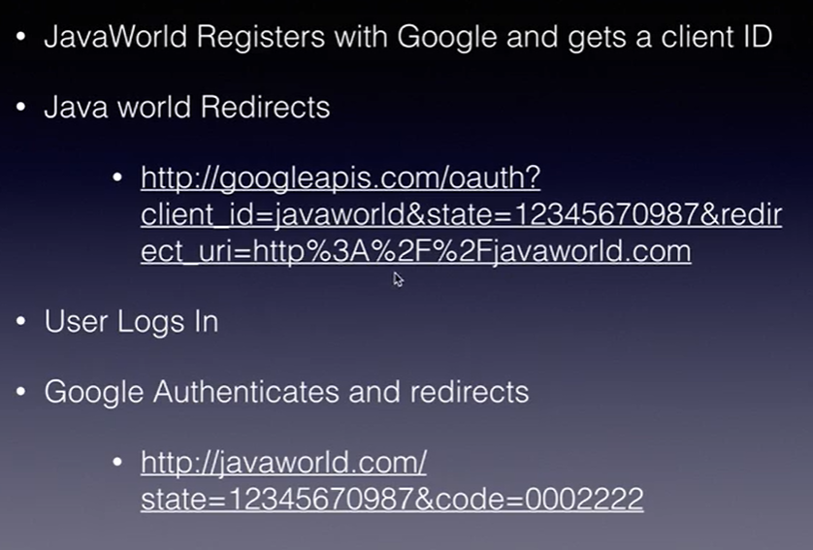





Client for attachment with Apache CFX



Rest Service





Spring mvc



Spring Rest







XmlRootElement not necessary, done automatically by Spring with Jackson libraries added on pom

Post is not cacheable

